1. A close up of a sign

   Description automatically generated with low confidence
2. **Agenda of this section**:
   1. How to unit test Repository Layer components?
3. 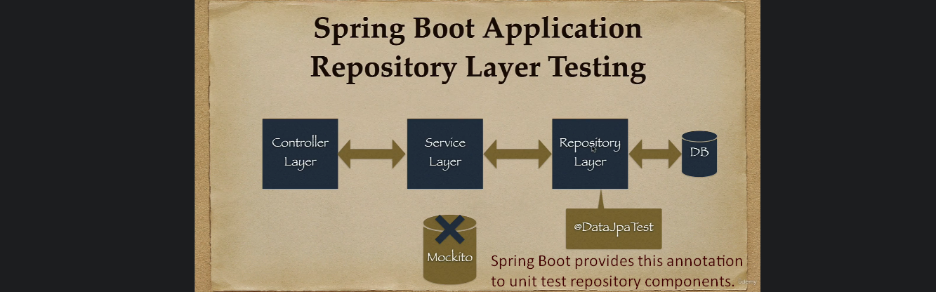
4. @**DataJpaTest**:
   1. This annotation is used to unit test repository components.
   2. Internally, this annotation uses in-memory h2 DB.
   3. We don’t need to use real DB like MySQL.
   4. We will not use Mockito as no further dependency.
   5. In next lectures, we will see more about this annotation.
5. Overview of this section:  
   A picture containing text, screenshot, book, font

   Description automatically generated
6. We will use BDD style as this provides a good structure.  
   Developer and QA can understand very easily.  
   A picture containing text, screenshot, font, design

   Description automatically generated  
   **GIVEN**: Setup, initialization.  
   **WHEN**: Actual Action.  
   **THEN**: To verify the action.